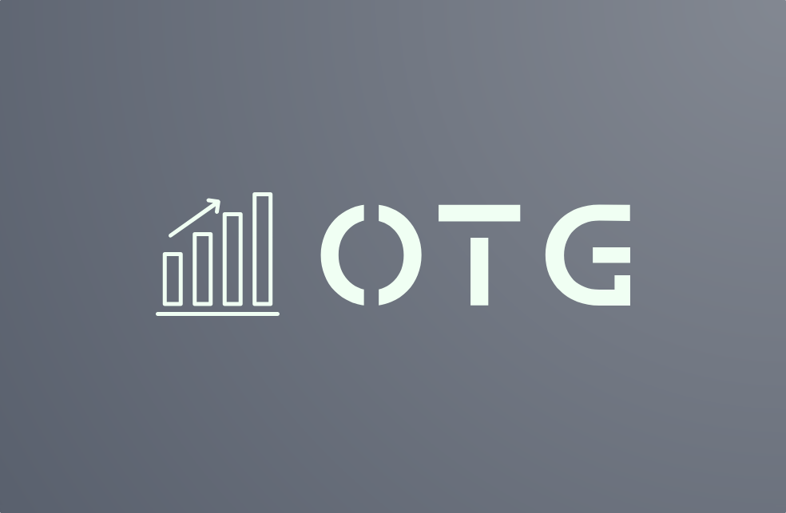

**TABLE OF CONTENTS**

TEAM MEMBERS 2

ABOUT THE OUR PROJECT 2

PROJECT DESCRIPTION 3

Teamwork. 3

Technologies used 3

COMPLETED TASKS 4

Come up with the idea 4

Make issues 4

Start with all the game modes 4

After choosing an idea we had to implement the game modes in the application. 4

Add the custom levels 4

Make the presentation and the documentation 4

# **TEAM MEMBERS**

|  |  |
| --- | --- |
|  | **Roles in the team** |
| **1** | Milko Barev – Scrum Trainer |
| **2** | Stanislav Radev – Backend developer |
| **3** | Martin Dimitrov – Backend developer |
| **4** | Petar Dimitrov – Backend developer |

# **ABOUT THE OUR PROJECT**

OTG (On The Grind) is a team of young and ambitious programmers that are keen on trading and want to give a tool to people to train themselves in the basics of crypto traiding.

# **PROJECT DESCRIPTION**

|  |  |  |
| --- | --- | --- |
|  | **Description** |  |
| **1** | The idea: We wanted to give the opportunity to try out trading and how you can use it to make a living. All for free! We think that trying a possible hustle to do for a living is quite important that’s why we wanted to emphasize on the simulator aspect. |  |
| **2** | Teamwork.  Our main communicating platform was Microsoft Teams. During the given time we wasted no time and started working on the project as soon as we had an idea. The scrum trainer gave objectives to the developers that made sure all of the criteria was met. |  |
| **3** | Technologies used  The technologies we used are **Visual Studio** as our main code editor, **GitHub** for collaborative work, **Git** as a source control tool, **Microsoft Teams** for connection and communication, **PowerPoint** for the presentation, **Word** for the documentation. |  |

# **COMPLETED TASKS**

|  |  |
| --- | --- |
|  | **Completed tasks** |
| **1** | Come up with the idea  We brainstormed some ideas until we find something all of us liked. |
| **2** | Make issues  We made a variety of issues in Github so that everybody knew what he had to do. We also made sure all of them were neatly put together in the project in Github. |
| **3** | Start with all the game modes  After choosing an idea we had to implement the live data fetch to a live chart that was shown in our application. We wanted the application to be as realistic as possible so that’s why we fetched live data. |
| **4** | Add the different sections  Our main objective was not only building a trading simulator but also linking that simulator to objectives like paying the rent, shopping, etc. We also included an input for a different income. |
| **5** | Make the presentation and the documentation  Every good project needs a good presentation and a well put together documentation so that the project has used all of its potential. |